Lab 10

Counters and Clock Divider
Name: Sualeh, Hamza, Ghazi, Sarosh | Student ID: 10303, 10346, 10345, 10314

10.1 Objective
After performing this lab, students should be able to:
- Learn about procedural statements to design sequential circuits
- Construct h_counter and v_counter for VGA controller
- Design clock divider

10.2 Introduction
In previous labs, you learnt how to develop Verilog HDL modules of basic logic gates using a continuous assignment (assign) statement to define the behavior of a circuit. The assign statement runs continuously without passing through any procedure.

i. Procedural Statements
In order to design a circuit which should execute for specific scenarios, there are other behavioral statements, categorized in Verilog as the structured procedural statements, called initial block and always block. These statements are the two most basic statements in behavioral modeling.
All other behavioral statements can appear only inside these structured procedural blocks. Each always and initial statement represents a separate activity flow in Verilog. Each activity flow starts at simulation time 0. The statements always and initial cannot be nested.

- a. initial Statement
All statements inside an initial statement constitute an initial block. An initial block starts at time 0, executes exactly once during a simulation, and then does not execute again. If there are multiple initial blocks, each block starts to execute concurrently at time 0. Each block finishes execution independently of other blocks. The initial blocks are typically used for initialization, monitoring waveforms and other processes that must be executed only once during the entire simulation run. Multiple behavioral statements must be grouped, typically using the keywords begin and end.

initial
m = 1'b0; //Single Statement; doesn’t need to be grouped
initial
begin
#5 = 1'b1;
#25 = 1'b0; //Multiple Statement; need to be grouped
end
endmodule

Figure 10. 1: Example module for initial block

In Figure 10. 1, note that the two initial statements start to execute in parallel at time 0. If a delay #<delay> is seen before a statement, the statement is executed <delay> time units after the current simulation time. After the execution of code in Figure 10. 1, ‘m’ is assigned the value of 1’b0 at zero simulation time unit, ‘a’ is assigned value of 1’b1 at 5 simulation time units and ‘b’ is assigned value of 1’b0 at 30 (i.e.,25+5) simulation time units.


The initial block is not synthesizable in design module i.e.,cannot be converted into a hardware schematic with digital elements. Its primary purpose is for settling sequence of values in simulations (i.e., test benches) and variable initializations.

b. always Statement
The always statement starts at time 0 and executes the statements in the always block continuously in a looping fashion. This statement is used to model a block of activity that is repeated continuously in a digital circuit. An example is a clock generator module that toggles the clock signal every half cycle. In real circuits, the clock generator is active from time 0 to as long as the circuit is powered on. Figure 10. 2 illustrates one method to model a clock generator in Verilog.

// Code your design here
module clock_gen (clock);
output clock;
reg clock;
//Initialize clock at time zero
initial
clock = 1’b0;
always
//Toggle clock every half-cycle (time period = 20) always
#10 clock = ~clock;
initial
#1000 $finish;
endmodule

Figure 10. 2: Example module for always block

In Figure 10. 2, the always statement starts at time 0 and executes the statement 𝑐𝑙𝑜𝑐𝑘 = ~𝑐𝑙𝑜𝑐𝑘 every 10-time units. Notice that the initialization of clock has to be done inside a separate initial statement. If we put the initialization of clock inside the always block, clock will be initialized every time the always is entered. Also, the simulation must be halted inside an initial statement. If there is no $stop or $finish statement to halt the simulation, the clock generator will run forever.

ii. Procedural Assignment
Procedural assignments update values of reg, integer, real, or time variables. The value placed on a variable will remain unchanged until another procedural assignment updates the variable with a different value. There are two types of procedural assignment statements: Blocking and Non-blocking.

- a. Blocking Assignments
Blocking assignment statements are executed in order, they are specified in a sequential block. The ‘=’ operator is used to specify blocking assignments.

x=0; y=1; //Scalar assignments
count = 0; //Assignment to integer variables
count = count + 1; // Assignment to an integer (increment)

Figure 10. 3: Examples of blocking assignment

In Figure 10. 3, the statement y = 1 is executed only after x = 0 is executed and count = 0 is executed after y = 1 is executed. The statement count = count + 1 is executed last. The behavior in a particular block is sequential in a begin-end block if blocking statements are used, because the statements can execute only in sequence.

- b. Non-blocking Assignments
Non-blocking assignments allow scheduling of assignments without blocking execution of the statements that follow in a sequential block. A ‘<=’ operator is used to specify non-blocking assignments.

reg x,y
reg (15:0) reg_a, reg_b;
integer count,z;
initial
begin
x = 0; y=1; z= 0; // blocking
count = 1; // blocking
count <= count + 1; // non-blocking
z <= count + y; // non-blocking
end

Figure 10. 4: Example for non-blocking assignment

In Figure 10. 4, the statements x = 0 through count = 1 are executed sequentially starting at time 0. Then the non-blocking assignment is processed at the same simulation time. After the execution of above code count will have value of 2 and z will also have value of 2.

iii. Delay based Timing Control
Delay-based timing control in an expression specifies the time duration between when the statement is encountered and when it is executed. Delays are specified by the symbol #. It is specified as a non-zero delay to the left of a procedural assignment.
reg x, y;
initial
begin
x = 0; // no delay control
#10 y = 1; // delay execution of y =1 by 10 units
end
Figure 10. 5: Example for delay-based timing control

In Figure 10. 5, the execution of a procedural assignment is delayed by the number specified by the delay control. Delay is always relative to the time when the statement is encountered. Thus, y =1 is executed after 10-time units once it is encountered in the activity flow.
Simulation time units can be defined by the following compiler directive. Below command define one nanosecond as simulation time unit.

timescale 1ns/1ps

iv. Event based Timing Control
An event is the change in the value on a register or a net. Events can be utilized to trigger execution of a statement or a block of statements. The ‘@’ symbol is used to specify an event control. Statements can be executed on changes in signal value or at a positive or negative transition of the signal value.
When the signal transits from level 0 to 1, that transition is known as positive or rising edge of the signal as shown in Figure 10. 6(a). Similarly, when the signal transits from level 1 to 0, it is known as negative or falling edge of the clock as shown in Figure 10. 6(b).

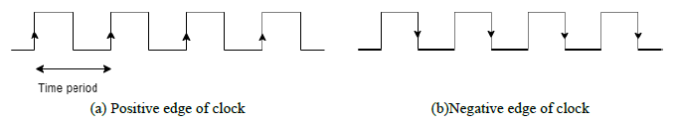

Figure 10. 6: Clock signal
In Verilog, the keyword ‘posedge’ is used for a positive transition and ‘negedge’ for negative transition. Figure 10. 7 shows some event-based control examples.

@(clock) q = d; //q =d is executed whenever signal clock changes value
@(posedge clock) q=d //q =d is executed whenever signal clock does a positive transition @(negedge clock) q=d //q =d is executed whenever signal clock does a negative transition always @(posedge clock) //always block is executed at positive edge of clock
begin
….
end

v. Clock Signal
A clock signal, shown in the figure below, is a particular type of signal that oscillates between a high and a low state and is used to coordinate actions of digital circuits. The period between the two consecutive positive edges or two consecutive negative edges is called a Time Period and is denoted with T (refer Figure 10. 6). Therefore, the frequency at which the digital circuit operates is defined by 𝑓 = 1𝑇⁄.
The Basys3 board operates at 100MHz clock frequency. To have lower clock frequency, clock divider module is designed using counters.
In the next two sections, you’ll implement the counter and clock divider circuit and then connect them together to work as a single module. This lab forms the foundation for VGA controller, the counters and clock divider design modules will be used in the next lab.

10.3 Counter
A counter is a sequential circuit that increments its count value upon each positive edge of the clock pulse. Counters are used in digital electronics for counting purposes, they can count specific event happening in the circuit.

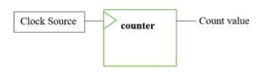
Figure 10. 8: Counter block

Implementations of 4-bit Counter
A 4-bit counter counts up to 2⁴ − 1 count value. Its Verilog implementation is shown in Figure 10. 9(a). Figure 10. 8 For each positive edge of clock pulse, the count registers increments until its value is 15. Once the count value exceeds 15 the count value is reset to 0.

(a)

// Code your design here
module counter_4bit(clk,count);
Input clk;
output [3:0] count;
reg [3:0] count:
initial count = 0;
always @ (posedge clk)
begin
if (count <= 15)
begin
| count <= count + 1;
end
else
begin
count <= 0;
end
end endmodule

(b)

// Code your testbench here
// or browse Examples
module tb();
reg clk;
wire [3:0) count;
Counter_4bit c1(.clk(clk),.count(count));
initial
clk = 1’b0;
always
#5 clk = ~clk;
initial
#200 $finish;
endmodule

Figure 10.9: 4-bit counter module (a) design (b) testbench

Task a)
Develop a 10-bit counter module, named h_counter, which should have following features:
a. Input: 1-bit clk signal
b. Outputs: 10-bit h_count signal and 1-bit trig_v signal.
c. Increment the counter output (h_count) at every positive edge of clock signal (clk) and count up to 799. To signal, counter have reached to its maximum value (i.e.,799), the trig_v signal sets to 1.
d. trig_v would be zero if count is less than 799.

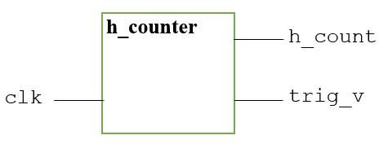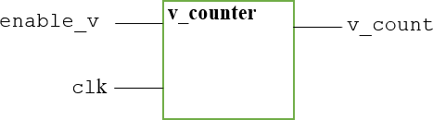

Figure 10. 10: h_counter module Figure 10. 11: v_counter module

Concept check:
Assuming that a time unit, in above mentioned testbench, is defined in nano seconds; what is the frequency at which the designed h_counter module would operate?

Task b)
Develop a 10-bit counter module, named v_counter,which should have following features:
- a. Inputs: 1-bit clk and enable_v signal
- b. Outputs: 10-bit v_count signal
- c. Increment the counter output (v_count) at every positive edge of clock signal (clk) and counts up to 524, only if enable_v signal is 1.
Modify the testbench provided in Figure 10. 9(b) to verify the functionality of your designed v_counter module.

10.4 Clock Divider
Basys3 board uses 100MHz clock (𝑇𝑖𝑚𝑒 𝑝𝑒𝑟𝑖𝑜𝑑=1(100×106)⁄ = 10𝑛𝑠) and the counter output is supposed to be updated at every positive edge of clock. While for driving VGA output, we require clock frequency of 25MHz. Therefore, we need to slow down the process by dividing the clock. In order to observe the output, we will run the counter at 25MHz (40ns).

Task c)
Write down the clock divider module shown in Figure 10. 12. This module has one input clk, and one output clk_d. In this experiment, the clk input will take the default clock (of 100 MHz)

// Code your design here
module clk_div (clk, clk_d);
parameter div_value = 1;
input clk;
output clk_d;
reg clk_d; reg count;
initial
begin
clk_d = 0; count = 0;
end
always @(posedge clk)
begin
if (count ==div_value)
count <= 0; // reset count
else
count <= count + 1; // count up
end
always @(posedge clk)
begin
if (count == div_value)
clk_d <= ~ clk_d; //toggle
end
end endmodule

Figure 10. 12

Verilog allows user to define a constant value with a help of a keyword parameter, as shown in line 3. A register is defined with the name count, which counts to a value of div_val = 1. The value of one-bit output clk_d is toggled every time when the counter becomes equal to div_val as shown in Figure 10. 13. div_val is calculated using formula

div_{value =} $\frac{input clock freqency}{2 ×desired clock frequency}-1$

Here input clock frequency is 100MHz and desired frequency is 25MHz.

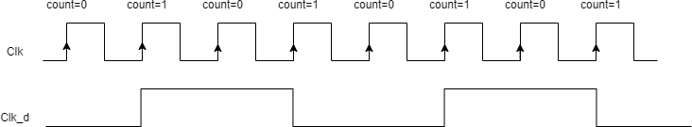
Figure 10. 13

10.5 Exercise
Write a Verilog module TopLevelModule that combines all the blocks from this lab according to the block diagram provided in Figure 10. 14. This module inputs clk signal and outputs h_count and v_count value. Use frequency divider to make the clock work on 5KHz frequency. Attach RTL Schematic. You are required to show your post-Lab results to the RA.
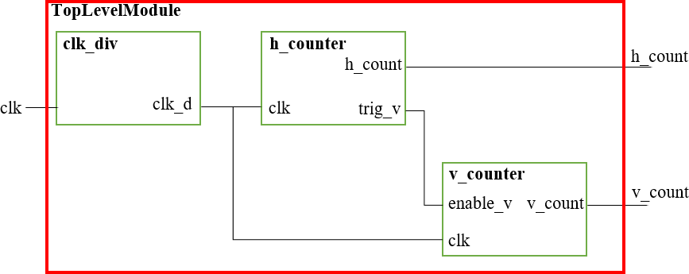
Figure 10. 14

Assessment Rubric
Lab 10
Counter and Clock divider

Name: | Student ID:

Marks Distribution:

 |  | LR2  Code | LR5  Results
In - Lab | Task a | 20 | 10
In - Lab | Task b | 10 | 10
In - Lab | Task c | - | -
Exercise |  | 20 | 20
Total Marks: 100 |  | /50 | /40
CLO Mapping |  | CLO2 | CLO2

Affective Domain Rubric |  | Points | CLO Mapped
AR 7 | Performance & Viva | /10 | CLO 4

CLO-LDL | Total Points | Points Obtained
2(pys-3) | 90
4(Aff-3) | 10
Total | 100

For description of different levels of the mapped rubrics, please refer to the provided Lab Evaluation Assessment Rubrics and Affective Domain Assessment Rubrics.

Lab Evaluation Rubrics
# | Assessment Elements | Level 1: Unsatisfactory | Level 2: Developing | Level 3: Good | Level 4: Exemplary
LR2 | Program/Co de/ Simulation Model/ Network Model | Program/code/simulati on model/network model does not implement the required functionality and has several errors. The student is not able to utilize even the basic tools of the software. | Program/code/simula tion model/network model has some errors and does not produce completely accurate results.  Student has limited command on the basic tools of the software. | Program/code/simula tion model/network model gives correct output but not efficiently implemented or implemented by computationally complex routine. | Program/code/simulati on /network model is efficiently implemented and gives correct output. Student has full command on the basic tools of the software.
LR5 | Results & Plots | Figures/ graphs / tables are not developed or are poorly constructed with erroneous results. Titles, captions, units are not mentioned. Data is presented in an obscure manner. | Figures, graphs and tables are drawn but contain errors. Titles, captions, units are not accurate. Data presentation is not too clear. | All figures, graphs, tables are correctly drawn but contain minor errors or some of the details are missing. | Figures / graphs / tables are correctly drawn and appropriate titles/captions and proper units are mentioned. Data presentation is systematic.
LR7 | Viva | Response shows a complete lack of understanding of the assigned / completed task | Response shows shallow understanding of the assigned task | Response shows substantial understanding of the assigned task | Response shows complete understanding of the completed task. The student is able to explain all the related concepts.

